AIM Innovation Showcase Application

# Sponsor

**Nominations must be submitted by an AASHTO member DOT willing to help promote the innovation.** If selected, the sponsoring DOT will be asked to present the innovation at the Innovation Showcase during the AASHTO Spring Meeting.

1. Sponsoring DOT (State): California Department of Transportation

2. Name and Title: Mehdi Mirjamali – TMS Maintenance Manager

3. Organization: California Department of Transportation

4. Street Address: 13892 Victoria St

5. City: Fontana

6. State: California

7. Zip Code: 92336

8. Email: jaime.jimenez@dot.ca.gov

9.Phone: (909) 693-9380

# Innovation Description (30 points)

The term “innovation” may include processes, products, techniques, procedures, and practices.

3. Name of the innovation:

TME Status List Database

4. Please describe the innovation.

The TMS Maintenance Engineering (TME) Status List Database is a tool that will be used to monitor, track, and display District 8 TMS Element Status and Communication in real-time. It will also show the recent history of TMS elements’ communication and its percentages.

5. What is the existing baseline practice that the innovation intends to replace/improve?

A TME can take an average of 40 hours checking the communication of each element manually under the best-case scenario.

6. What problems associated with the baseline practice does the innovation propose to solve?

The database uses ping automation and manual user input logging to maintain an up-to-date account of the TMS Elements and their operational status, thus reducing the communication check to approximately 1.50 hours. It can also provide a summarized report of elements and the account of their last communication timestamp, to ensure immediate action is taken as soon as an issue appears.

7. Briefly describe the history of its development.

The Caltrans District 8 TMS Maintenance Engineering (TME) group is responsible for monitoring the status and uptime health of the elements along the freeways. District 8 has close to 2,500 elements, and with a growing need for traffic management along District 8’s two counties, it becomes particularly difficult to check and identify the problem of each element every day.

8. What resources—such as technical specifications, training materials, and user guides—have you developed to assist with the deployment effort? If appropriate, please attach or provide weblinks to reports, videos, photographs, diagrams, or other images illustrating the appearance or functionality of the innovation below (if electronic, please provide a separate file). Please list your attachments or weblinks here.

The use of Visual Studio Code and phpMyAdmin aided the development of the TME Status List Database. The TME team has also created various manuals and a roadmap for nationwide launch.



# State of Development (10 points)

Innovations must be successfully deployed in at least one State DOT. The AIM selection process will favor innovations that have advanced beyond the research stage, at least to the pilot deployment stage, and preferably into routine use.

9. How ready is this innovation for implementation in an operational environment? Please select from the following options. Please describe.

Innovation is fully functional and yet to be piloted.

Innovation has been piloted successfully in an operational environment.

Innovation has been deployed multiple times in an operational environment.

Innovation is ready for full-scale implementation.

The TME Status List Database has been operational since April 2024 and is used daily by the TME team to monitor communication statuses and quickly access asset information when troubleshooting elements.

10. What additional development is necessary to enable implementation of the innovation for routine use?

The TME team is awaiting clearance for server access to continuously call on the ping automation function. Improvements to the automatic CCTV PTZ checks are still in the process. Additionally, the TMEs intend to utilize network management software in conjunction with the database (OpenNMS).

11. Do you have knowledge of other organizations using, currently developing, or showing interest in this innovation?  Yes  No

If so, please list organization names and contacts. (Shown interest)

|  |  |  |  |
| --- | --- | --- | --- |
| **Organization** | **Name** | **Phone** | **Email** |
| Caltrans HQ Maintenance | David Nguyen | (916) 531-6040 | David.Nguyen@dot.ca.gov |
| Caltrans HQ Maintenance | Harvin Signh | (916) 862-2436 | Harvin.Singh@dot.ca.gov |
| Caltrans Electrical Superintendent | Arik Jenkins | (916) 639-5813 | Arik.Jenkins@dot.ca.gov |

# Potential Payoff (30 points)

Payoff is defined as the combination of broad applicability and significant benefit or advantage over baseline practice.

12. Identify the top three benefits your DOT has realized from using this innovation. Describe the type and scale of benefits of using this innovation over baseline practice. Provide additional information, if available, using quantitative metrics, to describe the benefits.

|  |  |
| --- | --- |
| **Benefit Types** | **Please describe:** |
| Organizational Efficiency | TMEs can troubleshoot assets more efficiently. |
| Improved Asset Performance | TMEs can fix field elements more rapidly. |
| Cost Savings | TMEs spend less time with repetitive tasks, more time fulfilling work and duty roles. |

Provide any additional details below:

Pictures from the TME Status List Database:

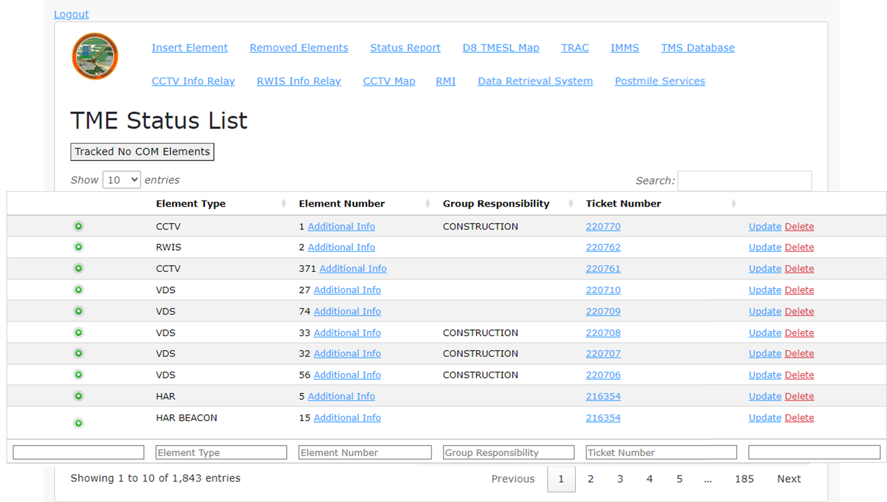

# Deployability (30 points)

The AIM selection process will favor innovations that can be adopted with a reasonable amount of effort and cost, commensurate with the payoff potential.

13. What challenges and/or lessons learned should other organizations be aware of before adopting this innovation?

There is a lot of research into server allocation and databases required before adopting this innovation. Additionally, gaining executive leadership support is difficult when immediate gratification is unavailable.

14. Please provide details of cost, effort, and length of time expended to deploy the innovation in your organization.

**Cost**: Cost can be quantifies using employee wages, however since the innovation was worked on concurrently to other TME tasks, the cost for this innovation is negligible.

**Level of Effort**: Lead TME for this innovation expended majority of their efforts while recruiting assistance from the remaining TMEs and Student Assistants.

**Time**: Approximately six months of dedication while tending to other responsibilities and delegated tasks.

15. To what extent might implementation of this innovation require the involvement of third parties, including vendors, contractors, and consultants? If so, please describe. List the type of expertise required for implementation.

The third parties involved would exclusively include software (e.g., ESRI ArcGIS for geolocating elements, Microsoft Outlook for automatic email notifications)